1. Using Html and CSS - Create a Google logo with the corresponding colour

pattern.

Google.html

<!DOCTYPE html>

<html lang="en">

  <head>

    <meta charset="UTF-8" />

    <meta http-equiv="X-UA-Compatible" content="IE=edge" />

    <meta name="viewport" content="width=device-width, initial-scale=1.0" />

    <title>Google</title>

    <link rel="stylesheet" href="google.css" />

  </head>

  <body>

    <div class="corner">

      <div class="mail">

        <div id="a">Gmail</div>

        <div id="a">Images</div>

      </div>

      <div class="header">

        <div class="logo">

          <img style="height: 20vh; width: 300px" src="./Google-Logo.png" />

        </div>

        <div>

          <input

            id="search"

            type="text"

            placeholder="Search Google or type a URL"

          />

        </div>

        <div style="margin-top: 5px">

          <input type="button" value="Google Search" />

          <input type="button" value="I'am feeling Lucky" />

        </div>

      </div>

    </div>

  </body>

</html>

Google.css

body {

    font-family: "Poppins", sans-serif;

}

.corner {

    background-image: url("./bg.jpg");

    background-repeat: no-repeat;

    background-size: cover;

}

.header {

    display: flex;

    justify-content: center;

    flex-direction: column;

    text-align: center;

    height: 100vh;

}

input {

    width: 10rem;

    height: 2rem;

    padding: 5px;

    border: 1px solid rgba(0, 0, 0, 0.164);

    cursor: pointer;

    box-shadow: 0 4px 8px 0 rgba(0, 0, 0, 0.2);

    color: rgba(0, 0, 0, 0.637);

}

.mail {

    display: flex;

    flex-direction: row;

    color: aliceblue;

    justify-content: right;

}

#a {

    font-size: small;

    margin: 5px;

    padding-top: 20px;

    padding-right: 15px;

    color: rgba(0, 0, 0, 0.959);

}

#search{

    border-radius: 50px;

    width: 30rem;

    padding: 6px;

    margin-bottom: 15px;

    border: 1px solid rgba(0, 0, 0, 0.212);

}

.logo{

    font-size: 70px;

    margin-bottom: 10px;

    margin-right: 6px;

    color: rgb(10, 10, 10);

}

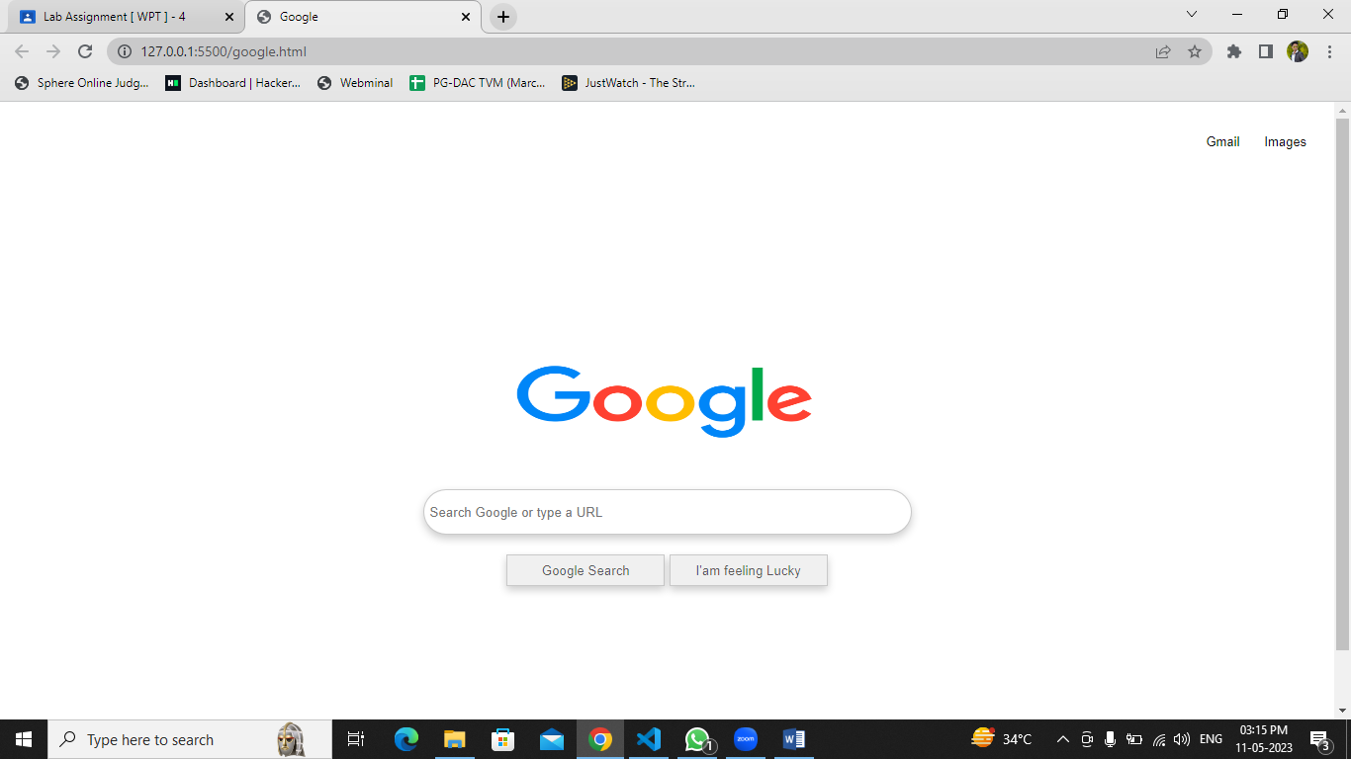

2. Apply inline, internal, and external CSS to change colours of certain text

portions, bold, Underline and italics certain words in the previously created

HTML resume form.

Resume.html

<html lang="en">

  <head>

    <meta charset="UTF-8" />

    <meta http-equiv="X-UA-Compatible" content="IE=edge" />

    <meta name="viewport" content="width=device-width, initial-scale=1.0" />

    <link rel="stylesheet" href="resume.css" />

    <title>My Resume</title>

  </head>

  <body>

    <div class="full">

      <div class="left">

        <div class="image">

          <img

            src="https://encrypted-tbn0.gstatic.com/images?q=tbn:ANd9GcRvq0MakGGWmg7DvTMvExML1LPFN6p-CtdEaP05XoLdWQ&usqp=CAU&ec=48665701"

            alt="gfg-logo"

            style="

              width: 100px;

              height: 100px;

              align-items: center;

              border: solid rgba(0, 0, 0, 0);

              border-radius: 50%;

            "

          />

        </div>

        <div class="Contact">

          <h2>Contact</h2>

          <p><b>Email id:</b>pareshdhopatgmail.com</p>

          <p><b>Mobile no :</b>8097543222</p>

        </div>

        <div class="Skills">

          <h2>Skills</h2>

          <ul>

            <li><b>Programming Languages : Java, C++,C </b></li>

            <li><b>Frontend : HTML5, CSS3, JavaScript, React</b></li>

            <li><b>Backend : Node.js,PHP</b></li>

          </ul>

        </div>

        <div class="Language">

          <h2>Language</h2>

          <ul>

            <li>English</li>

            <li>Marathi</li>

            <li>Hindi</li>

          </ul>

        </div>

        <div class="Hobbies">

          <h2>Hobbies</h2>

          <ul>

            <li>Playing cricket</li>

            <li>Swimming</li>

          </ul>

        </div>

      </div>

      <div class="right">

        <div class="name">

          <h1>Paresh Dhopat</h1>

        </div>

        <div class="title">

          <p>Full Stack Developer</p>

        </div>

        <div class="Summary">

          <h2>Summary</h2>

          <p>

            To secure a challenging position in a reputable organization to

            expand my learning knowledge and skill

          </p>

        </div>

        <div class="Experience">

          <h2>Experience</h2>

          <h3>Abc webdev pvt ltd - Senior Full Stack Developer</h3>

          <p>January 2022 to Present</p>

          <ul>

            <li>Actively engaged in web creative design and development.</li>

            <li>Designing project & planning</li>

          </ul>

          <h3>Xyz webdev pvt ltd - junior web developer</h3>

          <p>August 2021 to December 2021</p>

          <ul>

            <li>Actively engaged in web creative design and development.</li>

            <li>Designing project & planning</li>

            <li>Working on designing</li>

          </ul>

        </div>

        <div class="Education">

          <h2>Education</h2>

          <table>

            <tr style="margin: 2px">

              <th>University/college</th>

              <th>Passing year</th>

              <th>percentage/cgpa</th>

            </tr>

            <tr style="margin: 2px">

              <td>Mumbai University</td>

              <td>2019</td>

              <td>8.8</td>

            </tr>

            <tr>

              <td>Mumbai University</td>

              <td>2016</td>

              <td>70%</td>

            </tr>

            <tr>

              <td>Vidyanidhi Parekh High School</td>

              <td>2012</td>

              <td>76.91%</td>

            </tr>

          </table>

        </div>

        <div class="project">

          <ul>

            <li>

              <h2>Voice Bot for Agricultural</h2>

              <p>

                Farmers are not aware of the new emerging technologies and

                techniques So VoiceBot will help to increase their knowledge. We

                have built a system where the framers can resolve their queries

                about agriculture by using their phones.

              </p>

            </li>

            <li>

              <h2>Voice Recognition System</h2>

              <p>

                This Software allows user to use their voice to control the

                computer. For example, for a task to run a particular file, we

                simply say "run (filename)". The software will automatically

                detect the file with that name and do the task mentioned.

              </p>

            </li>

          </ul>

        </div>

      </div>

    </div>

  </body>

</html>

Resume.css

\* {

    margin: 0;

    padding: 0;

}

body {

    background-color: rgb(253, 254, 255);

    display: flex;

    justify-content: center;

    align-items: center;

}

.full {

    background-color: rgb(245, 239, 231);

    display: flex;

    justify-content: center;

    text-align: left;

}

.left {

    background-color: rgba(247, 114, 6, 0.815);

    padding: 20px;

}

.right {

    background-color: rgba(227, 239, 240, 0.678);

    padding: 20px;

}

.image,

.Contact,

.Skills,

.Language,

.Hobbies,

.title,

.Summary,

.Experience,

.Education,

.project {

    margin-bottom: 30px;

}

.h2 {

    background-color: rgb(4, 96, 150);

}

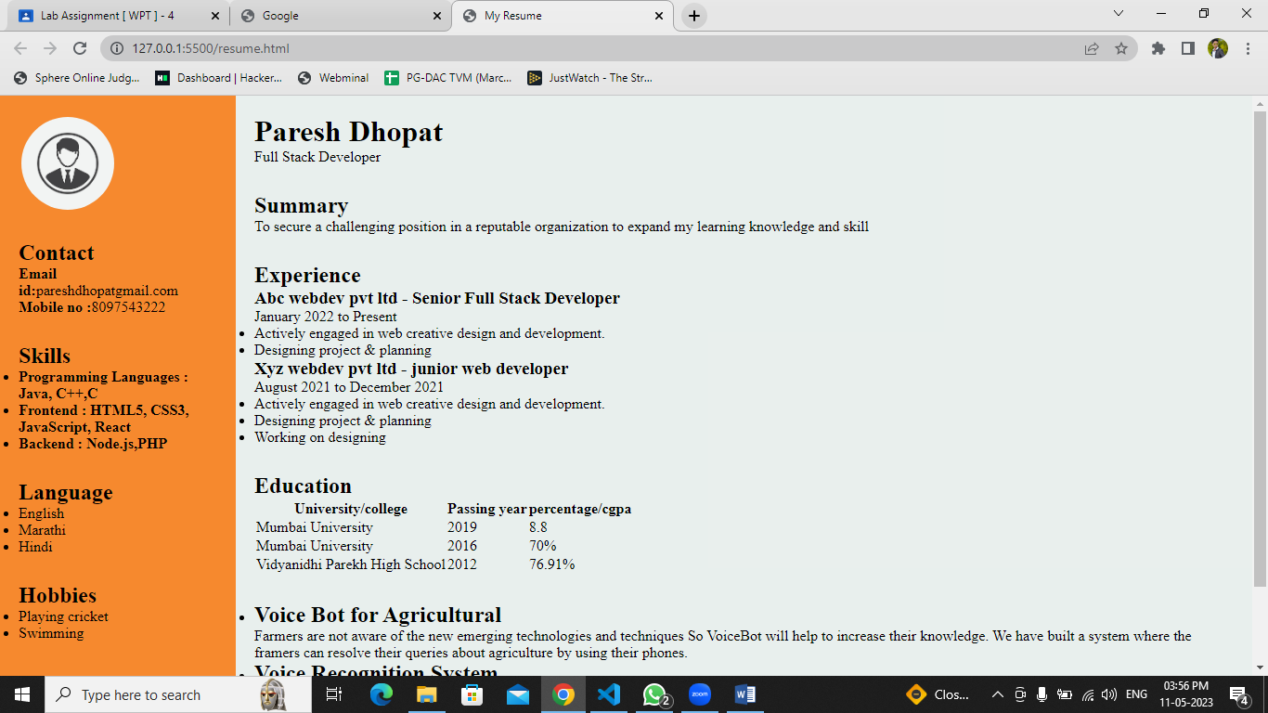

3. Write a JavaScript program to display Hello world.

Hello.html

<!DOCTYPE html>

<html lang="en">

  <head>

    <meta charset="UTF-8" />

    <meta http-equiv="X-UA-Compatible" content="IE=edge" />

    <meta name="viewport" content="width=device-width, initial-scale=1.0" />

    <title>Hello World using JS</title>

    <script src="hello.js"></script>

  </head>

  <body>

    <input type="button" value="Press here" onclick="hello()" />

  </body>

</html>

Hello.js

function hello() {

    alert("Hello World");

}

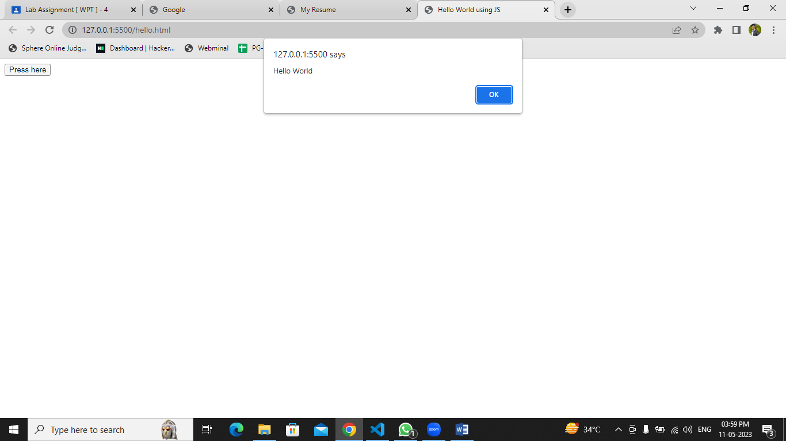

4. Try to write a java script program to create a simple calculator- sum of two

numbers.

Calculator.html

<!DOCTYPE html>

<html lang="en">

  <head>

    <meta charset="UTF-8" />

    <meta http-equiv="X-UA-Compatible" content="IE=edge" />

    <meta name="viewport" content="width=device-width, initial-scale=1.0" />

    <title>Calculator</title>

    <script src="calculator.js"></script>

  </head>

  <body>

    <h1 style="text-align: center">Calculator</h1>

    <div style="display: flex; justify-content: center; text-align: center">

      <input id="num1" type="text" placeholder="Enter number" />

      <input id="num2" type="text" placeholder="Enter number" />

      <input type="button" value="Sum" onclick="sum()" />

    </div>

  </body>

</html>

Calculator.js

function sum() {

    let num1 = document.querySelector("#num1").value;

    let num2 = document.querySelector("#num2").value;

    let sum=parseFloat(num1) + parseFloat(num2);

    alert("Sum of "+num1+ " and " +num2+ " is : "+sum)

}

